SMART FORMS

DRIVER PROGRAM

*\*&---------------------------------------------------------------------\**  
*\*& Report ZVJ_FORMDRIVER*  
*\*&---------------------------------------------------------------------\**  
*\*&*  
*\*&---------------------------------------------------------------------\**  
REPORT ZVJ_FORMDRIVER.  
  
DATA : it_makt TYPE ZDEMO_TB_MAKT.  
  
select matnr spras maktx from makt into table it_makt UP TO 10 ROWS.  
 CALL FUNCTION '/1BCDWB/SF00000042'  
 EXPORTING  
*\* ARCHIVE_INDEX =*  
*\* ARCHIVE_INDEX_TAB =*  
*\* ARCHIVE_PARAMETERS =*  
*\* CONTROL_PARAMETERS =*  
*\* MAIL_APPL_OBJ =*  
*\* MAIL_RECIPIENT =*  
*\* MAIL_SENDER =*  
*\* OUTPUT_OPTIONS =*  
*\* USER_SETTINGS = 'X'*  
 it_makt = it_makt  
*\* IMPORTING*  
*\* DOCUMENT_OUTPUT_INFO =*  
*\* JOB_OUTPUT_INFO =*  
*\* JOB_OUTPUT_OPTIONS =*  
 EXCEPTIONS  
 FORMATTING_ERROR = 1  
 INTERNAL_ERROR = 2  
 SEND_ERROR = 3  
 USER_CANCELED = 4  
 OTHERS = 5  
 .  
 IF sy-subrc <> 0.  
*\* Implement suitable error handling here*  
 ENDIF.  
  
*\* CALL FUNCTION '/1BCDWB/SM00000031'*  
*\* EXPORTING*  
*\*\* /1BCDWB/DOCPARAMS =*  
*\* it_maktt = it_makt*  
*\*\* IMPORTING*  
*\*\* /1BCDWB/FORMOUTPUT =*  
*\* EXCEPTIONS*  
*\* USAGE_ERROR = 1*  
*\* SYSTEM_ERROR = 2*  
*\* INTERNAL_ERROR = 3*  
*\* OTHERS = 4*  
*\* .*  
*\* IF sy-subrc <> 0.*  
*\*\* Implement suitable error handling here*  
*\* ENDIF.*

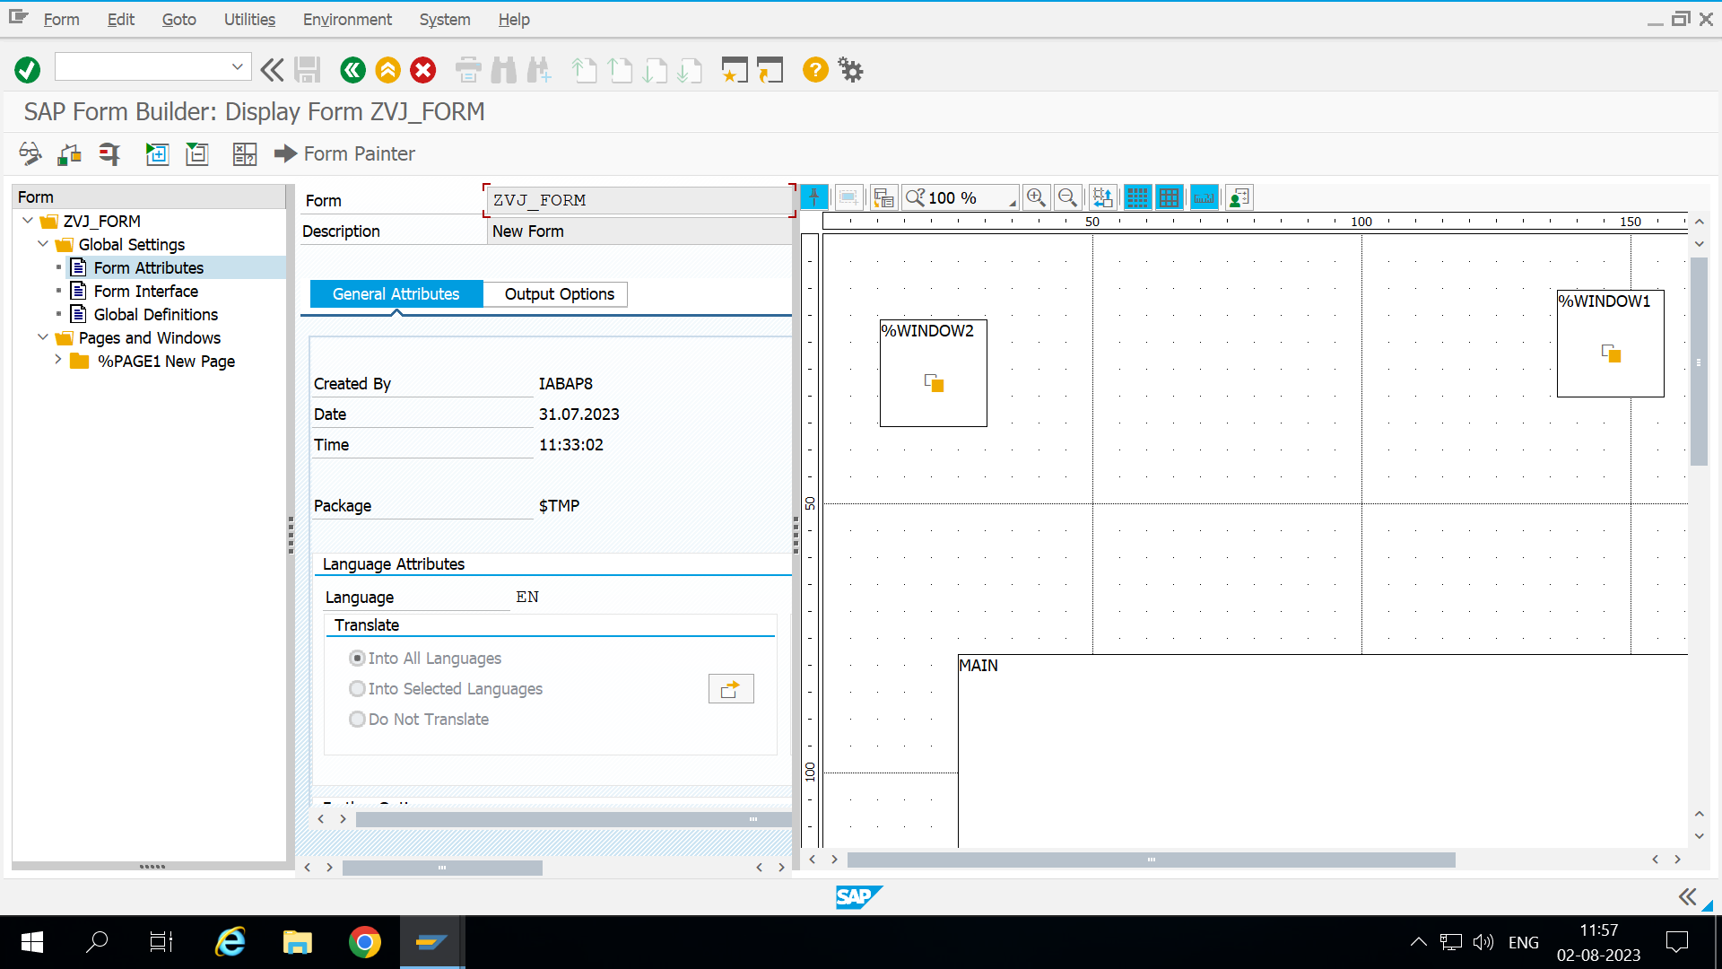

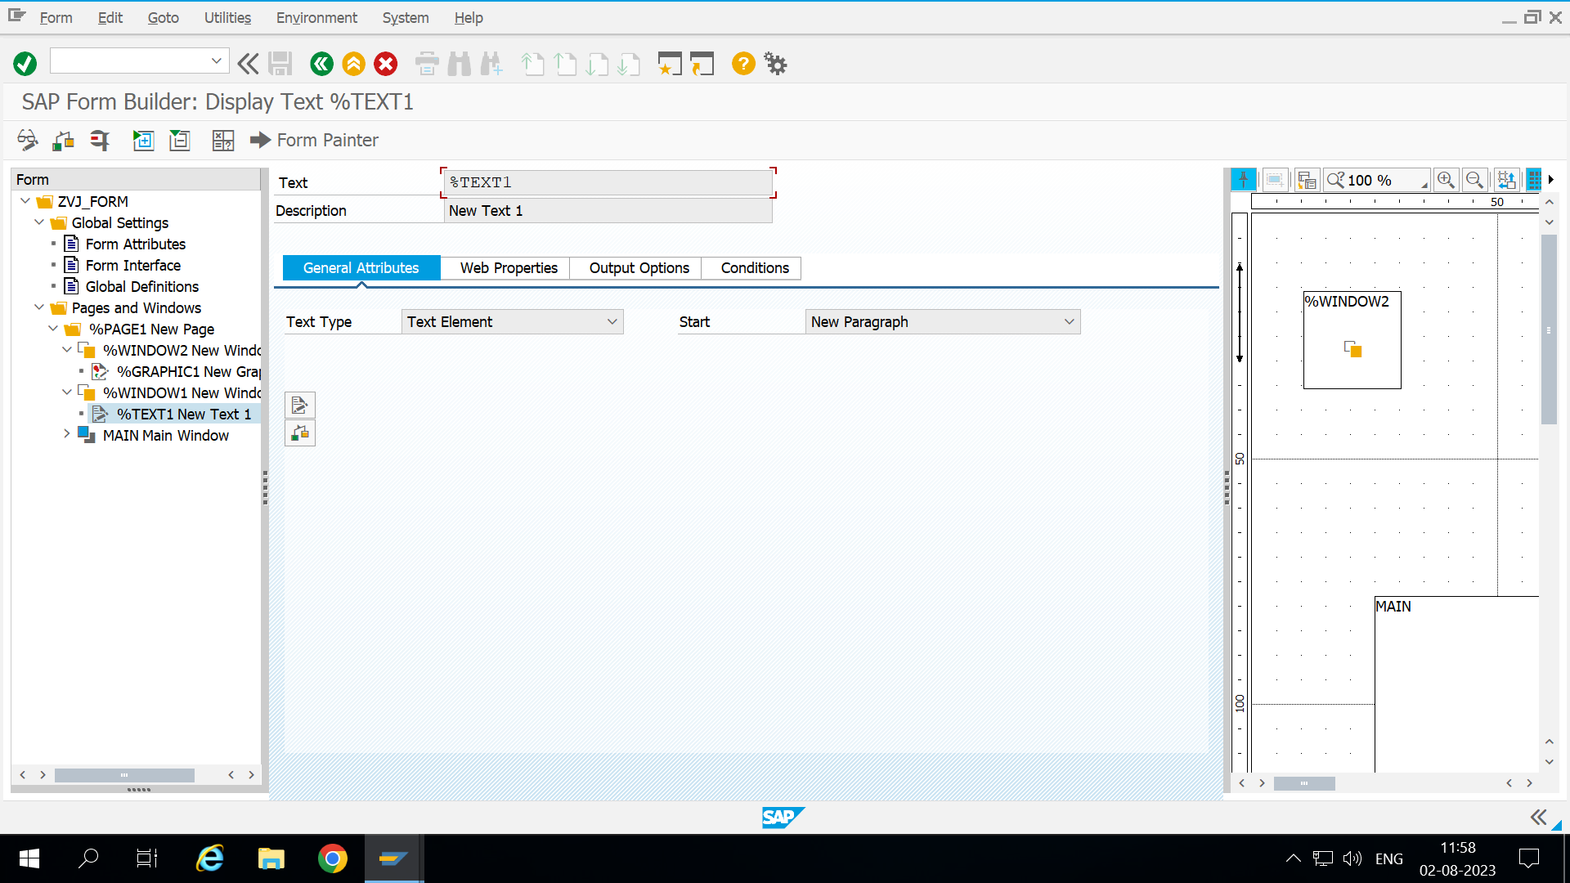

OUTPUT

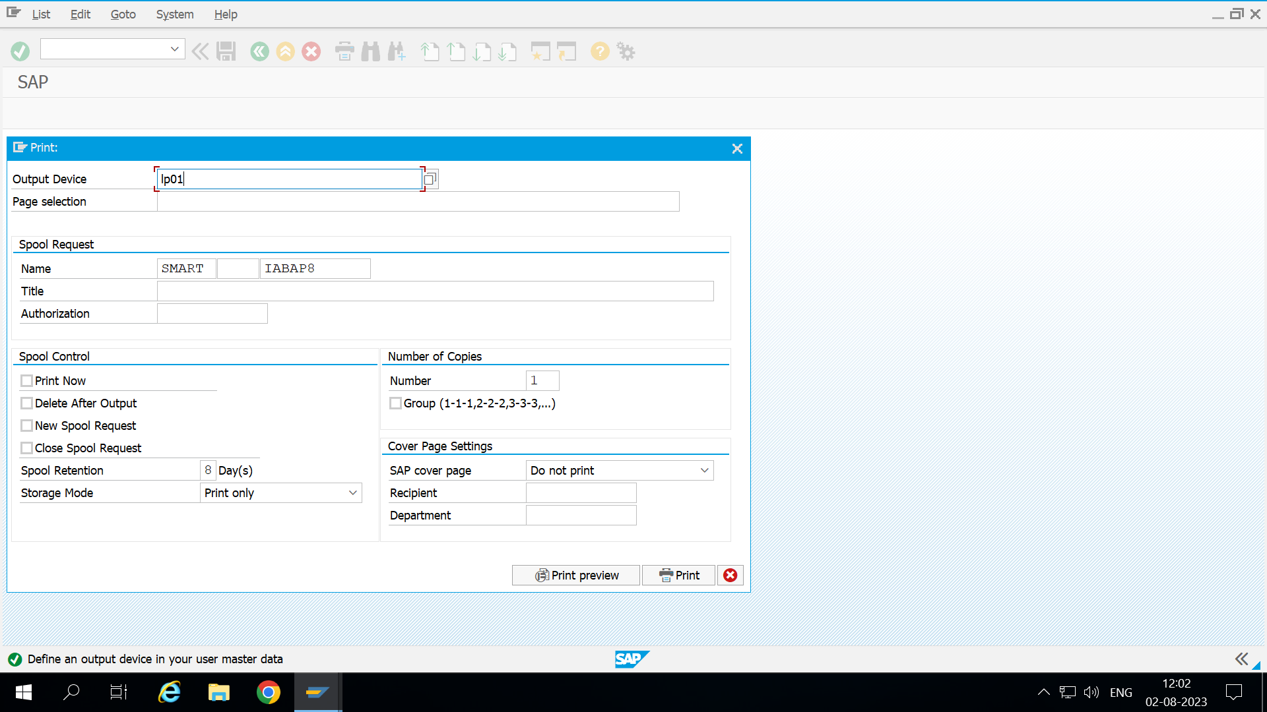

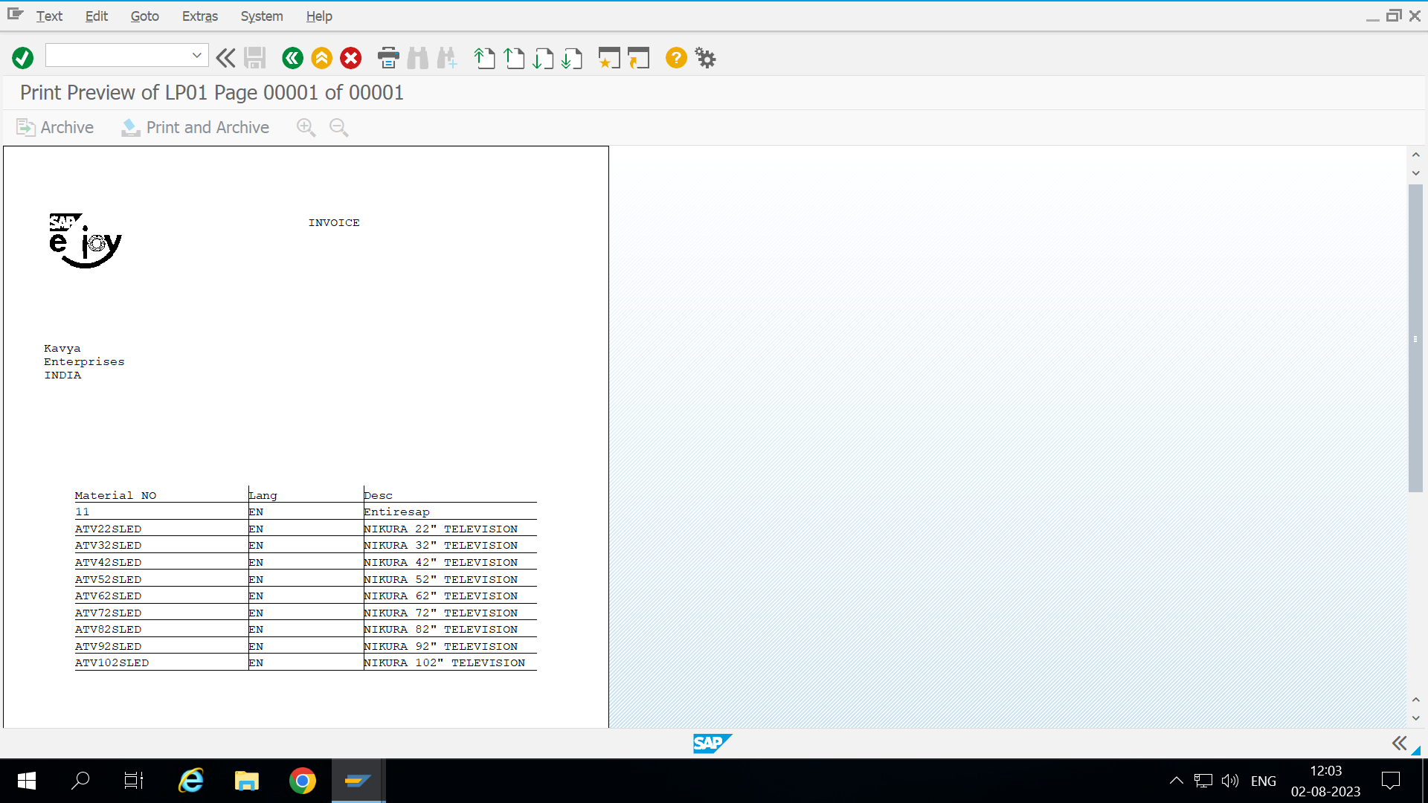

Views:

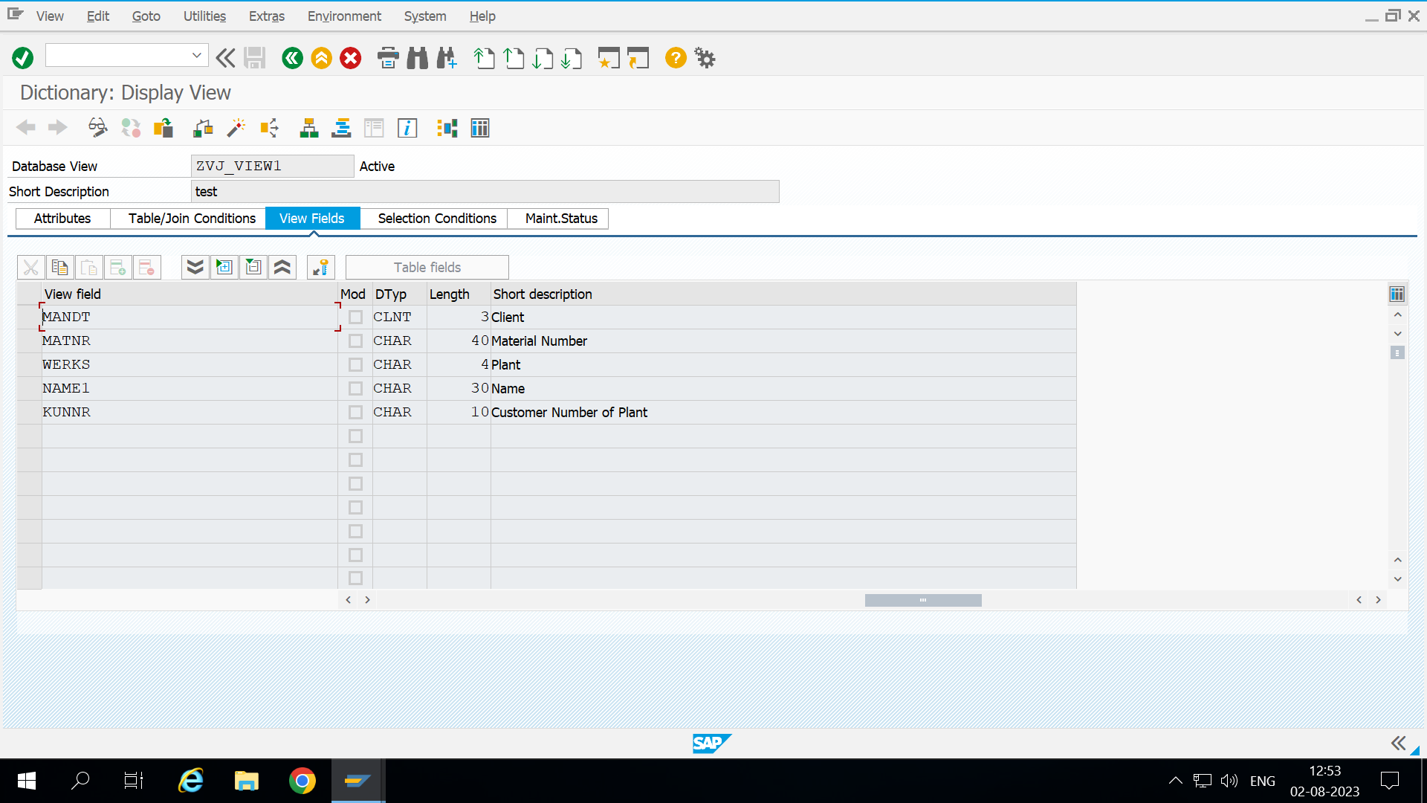

*\*&---------------------------------------------------------------------\**  
*\*& Report ZVJ_VIEW*  
*\*&---------------------------------------------------------------------\**  
*\*&*  
*\*&---------------------------------------------------------------------\**  
REPORT zvj_view.  
  
DATA it_plant TYPE STANDARD TABLE OF zvj_view1.  
  
PARAMETERS p_matnr TYPE zvj_view1 MATCHCODE OBJECT zvj_coll.  
  
SELECT * FROM zvj_view1 INTO TABLE it_plant UP TO 15 ROWS.  
  
cl_salv_table=>factory(  
*\* EXPORTING*  
*\* list_display = if_salv_c_bool_sap=>false " ALV Displayed in List Mode*  
*\* r_container = " Abstract Container for GUI Controls*  
*\* container_name =*  
 IMPORTING  
 r_salv_table = DATA(o_alv) *" Basis Class Simple ALV Tables*  
 CHANGING  
 t_table = it_plant  
).  
*\*CATCH cx_salv_msg. " ALV: General Error Class with Message*  
  
 o_alv->display( ).

OUTPUT

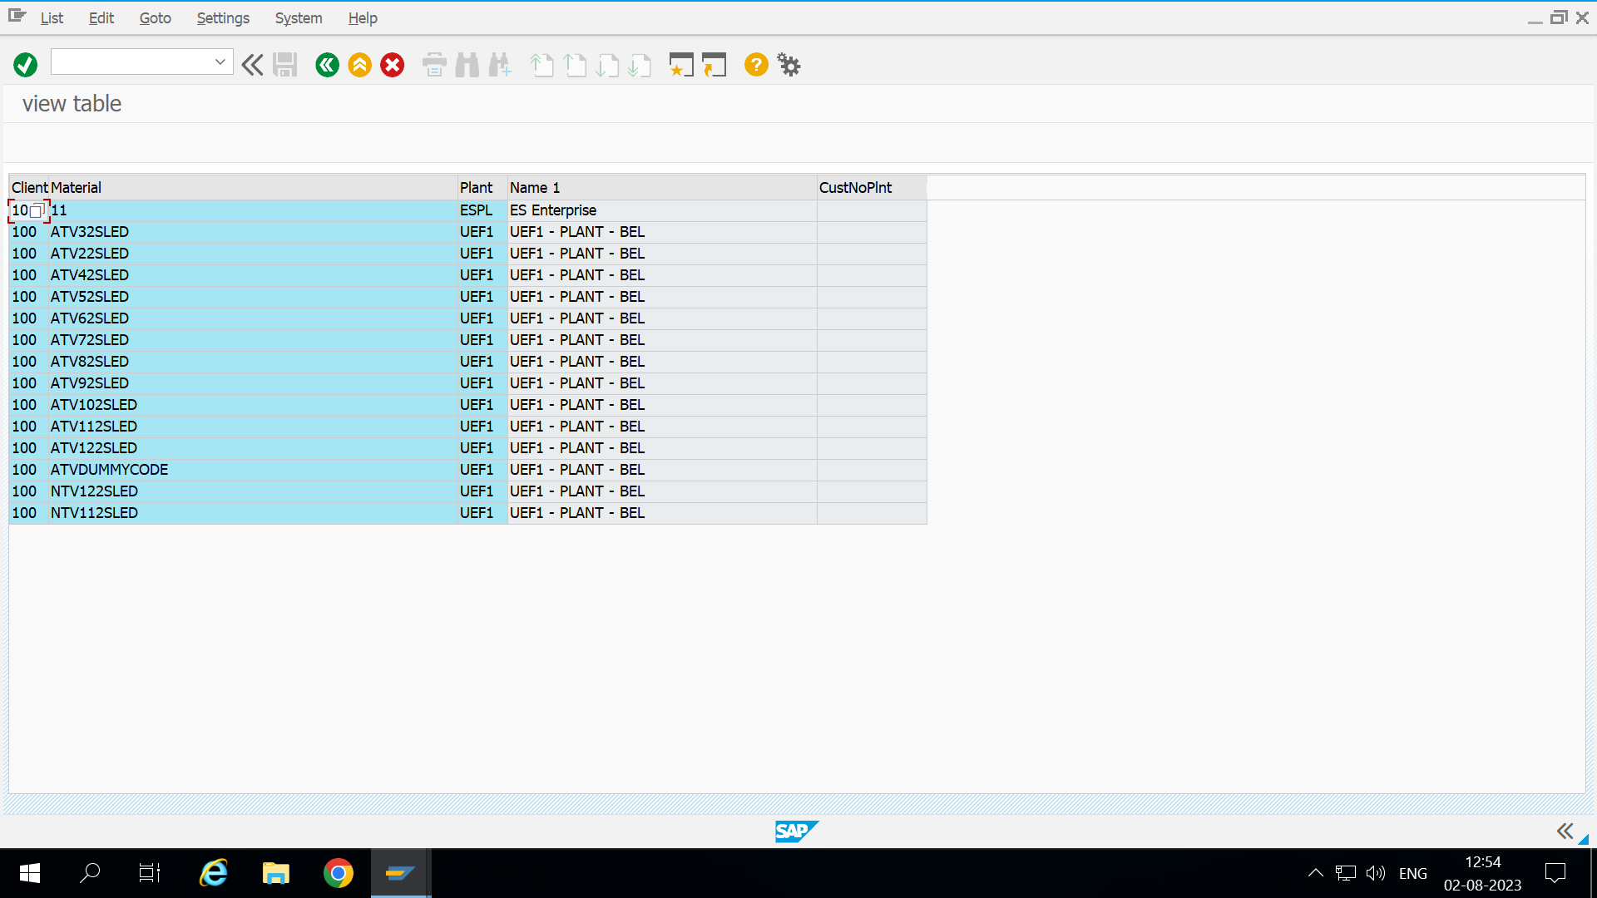

CDS VIEWS

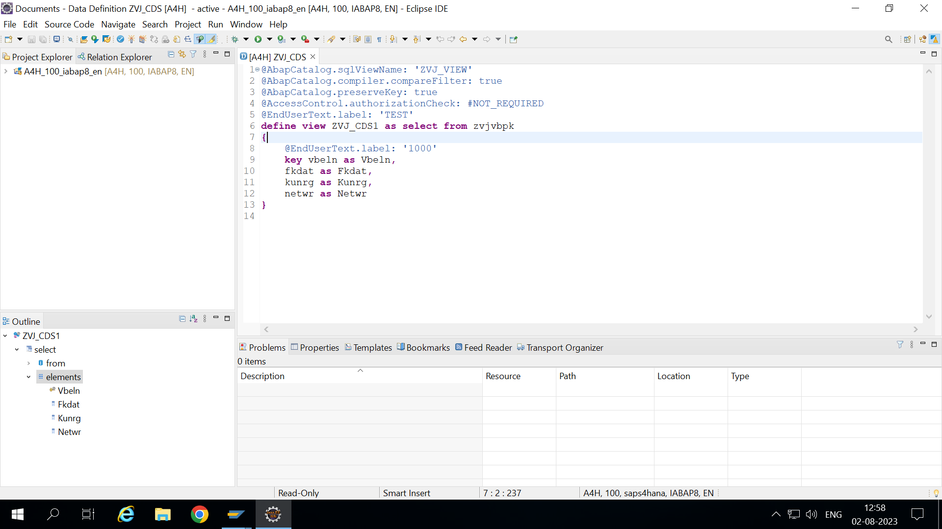

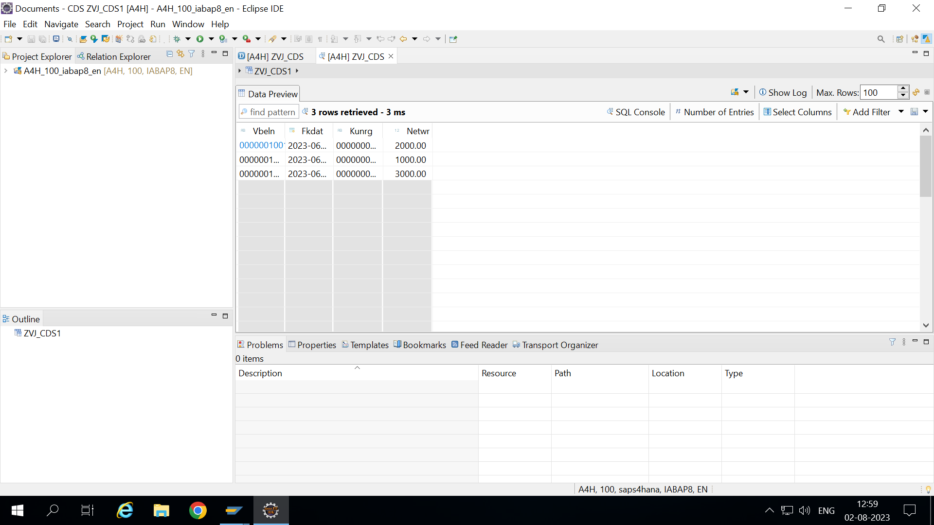

**OData services:**

